**SPAIN TELEMEDICINE MARKET**

According to Intelli, the Spain Telemedicine Market was valued at USD 3,670 million in 2024 and is projected to reach USD 9289.33 million by 2032, growing at a CAGR of 13.21% during the forecast period.

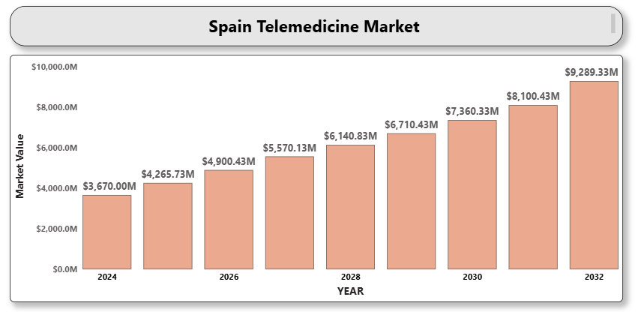

The rapid digitalization of healthcare, increasing internet penetration, and high smartphone usage are accelerating telemedicine adoption in Spain. The COVID-19 pandemic further catalyzed this shift by prompting widespread acceptance of remote consultations and virtual care platforms. Key healthcare institutions and private hospitals now integrate video conferencing, e-prescriptions, and AI-assisted diagnostics into routine care.

**Spain Telemedicine Market Definition**

Telemedicine refers to the practice of delivering healthcare services remotely using telecommunications technology. It includes virtual consultations, remote monitoring, tele-radiology, tele-ICU, and mobile health applications. Telemedicine enables patients to access medical expertise regardless of geographic barriers, improving access, efficiency, and continuity of care.

In Spain, telemedicine is gaining prominence across primary care centers, hospitals, and private healthcare providers. The technology facilitates timely healthcare access in rural and underserved regions, supports chronic disease management, and reduces the burden on emergency departments. Integration with electronic health records and government-backed digital health initiatives are enhancing its adoption.

**Spain Telemedicine Market Overview**

Spain’s aging population and high prevalence of chronic conditions such as diabetes, hypertension, and cardiovascular diseases are key drivers. Telemedicine offers convenient and cost-effective care options for ongoing disease management and follow-ups. Additionally, the Ministry of Health’s National Digital Health Strategy supports the implementation of remote health services as part of broader e-health transformation goals.

Collaborations between healthcare providers, IT vendors, and telecom operators are strengthening the telehealth infrastructure. Market players are also launching AI-integrated platforms with multilingual support and wearable health monitoring capabilities to improve patient outcomes and reduce clinical workloads.

**Spain Telemedicine Market Segment Analysis**

**By Component**

* **Software**: Includes video conferencing tools, mobile health apps, and integrated telehealth platforms used for virtual consultations and health data sharing.
* **Hardware**: Comprises digital diagnostic devices, webcams, wearable sensors, and remote monitoring tools.
* **Services**: Encompasses platform deployment, training, technical support, and system integration services.

**By Mode of Delivery**

* **Web-based**: Widely used due to its flexibility and ease of integration with existing hospital IT systems.
* **Cloud-based**: Gaining popularity for scalability, data storage, and interoperability across healthcare institutions.
* **On-premise**: Preferred by large hospitals for tighter data control and customization.

**By Application**

* **Teleradiology**: Enables remote interpretation of imaging data, widely adopted in radiology departments and diagnostic labs.
* **Telepathology**: Used for sharing pathology slides and enabling remote diagnosis.
* **A close-up of hands holding a tablet and a pen

  Description automatically generatedTelecardiology**: Supports real-time ECG transmission and cardiology consultations.
* **Telepsychiatry**: Increasingly adopted for mental health support and counseling.
* **General Consultation**: Covers primary care and routine patient consultations across multiple specialties.

**By End User**

* **Hospitals**: Implement telemedicine to enhance service delivery and improve patient management.
* **Homecare Settings**: Rising demand due to preference for remote follow-ups and chronic disease monitoring.
* **Clinics**: Offer teleconsultations to expand reach and optimize appointment scheduling.
* **Others (Insurance Providers, Pharmacies)**: Use telemedicine for policy services and e-prescriptions.

**Spain Telemedicine market Competitive Landscape**

The Spain telemedicine market features a competitive mix of local digital health startups and global telehealth solution providers. Companies compete based on platform usability, security features, AI capabilities, and integration with national health records.

**Key Profiles of Spain Telemedicine market**

* Teladoc Health
* Siemens Healthineers
* Medtronic
* Doctolib
* Babylon Health
* Global Telemedicine Group
* Ever Health
* A close-up of hands holding a tablet and a pen

  Description automatically generatedVIVIA Telemedicine
* Infermedica
* Savana
* Cisco Systems, Inc.
* eConsult
* Docline

**Key Developments**

* **On April 17, 2025**, **DocNow** announced the launch of **DocNow Telehealth**, a secure virtual care platform powered by Zoom. Tailored specifically for providers in **Skilled Nursing Facilities (SNFs)**, **Long-Term Care (LTC)**, and **Home Health** settings, the platform enhances remote care delivery and streamlines virtual consultations within post-acute care environments.
* In Spain, **2024 marks the year of consolidation for telemedicine**, building on the technological advancements and successful implementations achieved throughout 2023.

**Market Attractiveness**

Spain is a promising telemedicine market owing to its strong digital infrastructure, proactive government policies, and growing demand for healthcare decentralization. The shift toward value-based care and aging demographics further fuel telehealth innovation and scalability.

**Porter’s Five Forces Analysis**

* **Threat of New Entrants**: Moderate, due to the requirement for data security compliance and platform certification.
* **Bargaining Power of Suppliers**: Low to moderate, depending on technology sourcing.
* **A close-up of hands holding a tablet and a pen

  Description automatically generatedBargaining Power of Buyers**: High, driven by multiple platform options and user expectations for data privacy.
* **Threat of Substitutes**: Low, with limited viable alternatives for remote care.
* **Competitive Rivalry**: High, as numerous players strive to differentiate via innovation and service quality.

**Table of Contents**

1. **Introduction of Spain Telemedicine Market**
   * 1.1 Overview of the Market
   * 1.2 Scope of Report
   * 1.3 Assumptions
2. **Executive Summary**
3. **Research Methodology**
   * 3.1 Data Mining
   * 3.2 Validation
   * 3.3 Primary Interviews
   * 3.4 List of Data Sources
4. **Spain Telemedicine Market Outlook**
   * 4.1 Market Definition
   * 4.2 Market Overview
   * 4.3 Porter’s Five Forces Model
   * 4.4 Value Chain Analysis
5. **Market, by Component**
   * 5.1 Software
   * 5.2 Hardware
   * 5.3 Services
6. **Market, by Mode of Delivery**
   * 6.1 Web-based
   * 6.2 Cloud-based
   * 6.3 On-premise
7. **Market, by Application**
   * 7.1 Teleradiology
   * 7.2 Telepathology
   * 7.3 TelecardiologyA close-up of hands holding a tablet and a pen

     Description automatically generated
   * 7.4 Telepsychiatry
   * 7.5 General Consultation
8. **Market, by End User**
   * 8.1 Hospitals
   * 8.2 Homecare Settings
   * 8.3 Clinics
   * 8.4 Others
9. **Competitive Landscape**
   * Overview
   * Company Market Rankin
   * A close-up of hands holding a tablet and a pen

     Description automatically generatedKey Development Strategies
10. **Company Profiles**

**10.1 Teladoc Health**  
10.1.1 Overview  
10.1.2 Financial Performance  
10.1.3 Product Outlook  
10.1.4 Key Developments

**10.2 Siemens Healthineers**  
10.2.1 Overview  
10.2.2 Financial Performance  
10.2.3 Product Outlook  
10.2.4 Key Developments

**10.3 Medtronic**  
10.3.1 Overview  
10.3.2 Financial Performance  
10.3.3 Product Outlook  
10.3.4 Key Developments

**10.4 Doctolib**  
10.4.1 Overview  
10.4.2 Financial Performance  
10.4.3 Product Outlook  
10.4.4 Key Developments

**10.5 Babylon Health**  
10.5.1 Overview  
10.5.2 Financial Performance  
10.5.3 Product Outlook  
10.5.4 Key Developments

**10.6 Global Telemedicine Group**  
10.6.1 Overview  
10.6.2 Financial Performance  
10.6.3 Product Outlook  
10.6.4 Key Developments

**10.7 Ever Health**  
10.7.1 Overview  
10.7.2 Financial Performance  
10.7.3 Product Outlook  
10.7.4 Key Developments

**10.8 VIVIA Telemedicine**  
10.8.1 Overview  
10.8.2 Financial Performance  
10.8.3 Product Outlook  
10.8.4 Key Developments

**10.9 Infermedica**  
10.9.1 Overview  
10.9.2 Financial Performance  
10.9.3 Product Outlook  
10.9.4 Key Developments

**10.10 Savana**  
10.10.1 Overview  
10.10.2 Financial Performance  
10.10.3 Product Outlook  
10.10.4 Key Developments

**10.11 Cisco Systems, Inc.**  
10.11.1 Overview  
10.11.2 Financial Performance  
10.11.3 Product Outlook  
10.11.4 Key Developments

**10.12 eConsult**  
10.12.1 Overview  
10.12.2 Financial Performance  
10.12.3 Product Outlook  
10.12.4 Key Developments

**10.13 Docline**  
10.13.1 Overview  
10.13.2 Financial Performance  
10.13.3 Product Outlook  
10.13.4 Key Developments

1. **Key Developments**
   * + Product Launches/Developments
     + Mergers and Acquisitions
     + Business Expansions
2. **Appendix**

* 12.1 Related Research